**Consulting Report**

Table of Contents

1. INTRODUCTION 1

2. PROJECT DESCRIPTION 1

3. PROBLEM STATEMENT 1

4. PROBLEM ANALYSIS 1

5. SOURCES OF DATA 10

6. SUMMARY OF DATA MINING 11

7. PROPOSED SOLUTION FOR CUSTOMERS 12

8. TOOLS 26

9. CONCLUSION 26

# INTRODUCTION

It's always wonderful to see services customized to your needs. Businesses try to understand your behavior and adjust their offerings so as to ensure you feel attached to their services.

# PROJECT DESCRIPTION

**Insaid Telecom**, one of the leading telecom players, understands that customizing offering is very important for its business to stay competitive. Currently, Insaid Telecom is seeking to leverage behavioral data from more than 60% of the 50 million mobile devices active daily in India to help its clients better understand and interact with their audiences.

In this **consulting assignment**, Insaidians are expected to build a dashboard to understand user's demographic characteristics based on their mobile usage, geolocation, and mobile device properties. Doing so will help millions of developers and brand advertisers around the world pursue  
data-driven marketing efforts which are relevant to their users and catered to their preferences

# PROBLEM STATEMENT

To help the customer, the consultants are expected to have depth of clarity in the underlying data. Do help the company understand what the right way forward is and suggest actionable insights from marketing and product terms

# PROBLEM ANALYSIS

In order to help the customers, we consultants made depth analysis by reading the data and here below are our analyzing criteria by few plots

1. **Frequency of events recorded (mobile usage) by states**

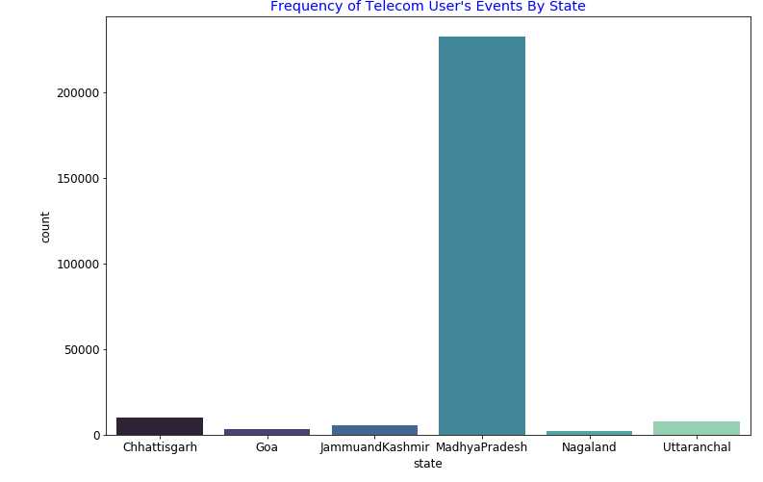

1. **Frequency of events by gender**

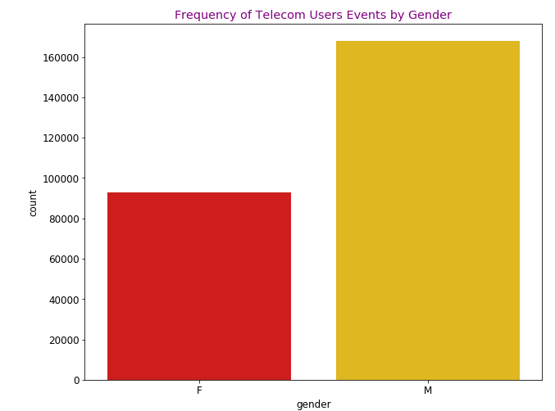

1. **Frequency of events by group**

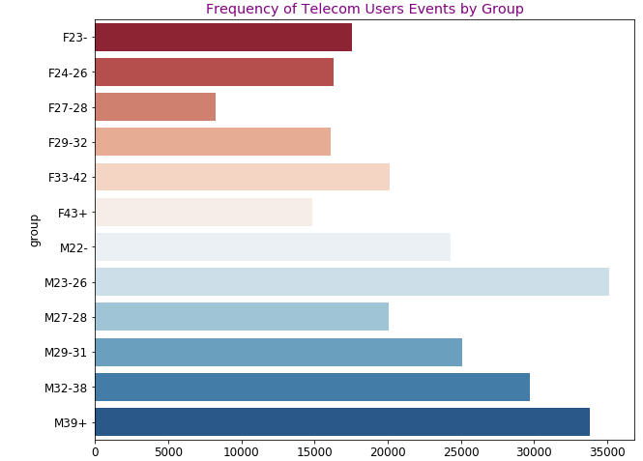

1. **Frequency of events recorded by age vs state**

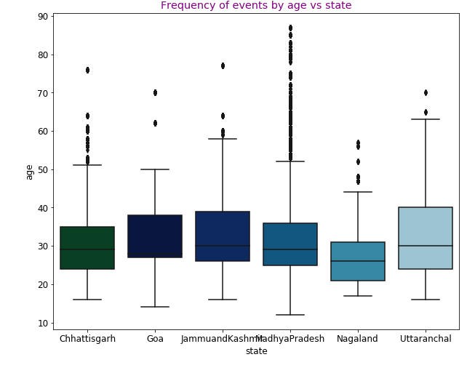

1. **Grouping by state, age, gender and Plotting Frequency of events by State, age and gender** 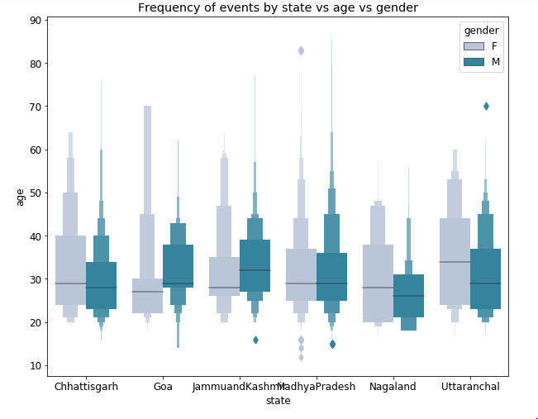
2. **Grouping by State, City, Age and Plotting Frequency of events by state vs city vs age**

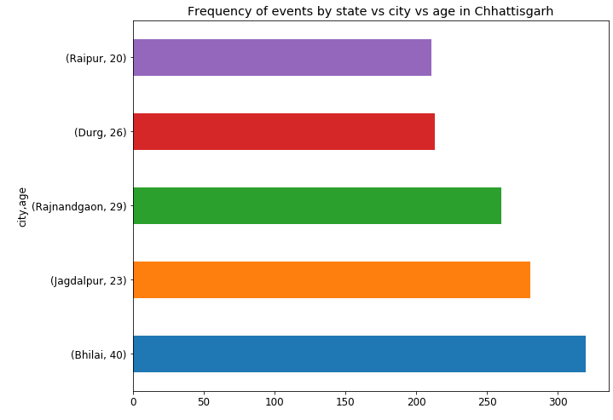

1. **Frequency of Events by State Vs Phone Brand**

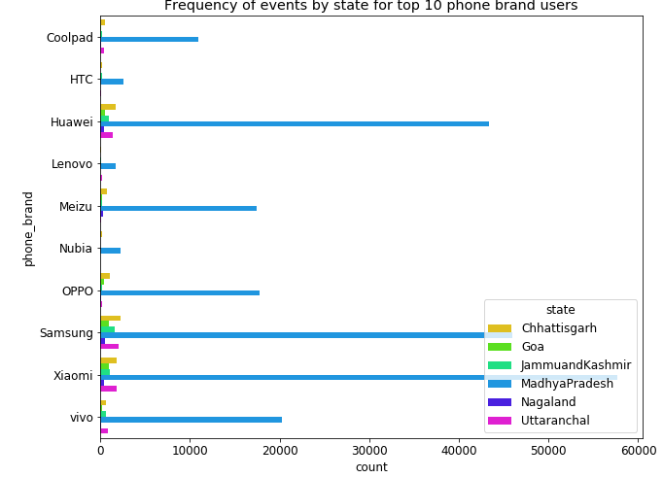

1. **Grouping phone brand, gender, state and Plotting to know frequency of events by Phone brand vs gender vs state**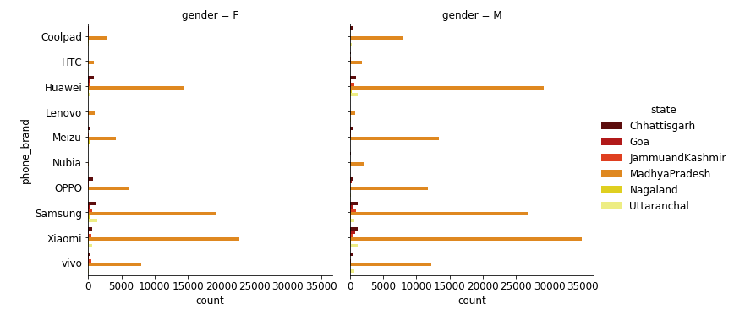
2. **Grouping by phone brand, state, age and plotting to know frequency of events by Phone Brand Vs State Vs Age**

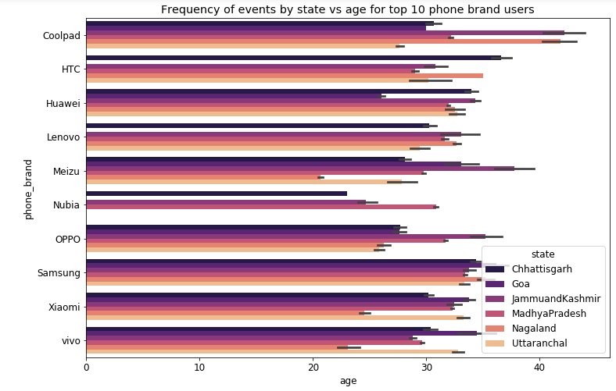

1. **Top 10 Models of one of the top phone brand(Samsung)**

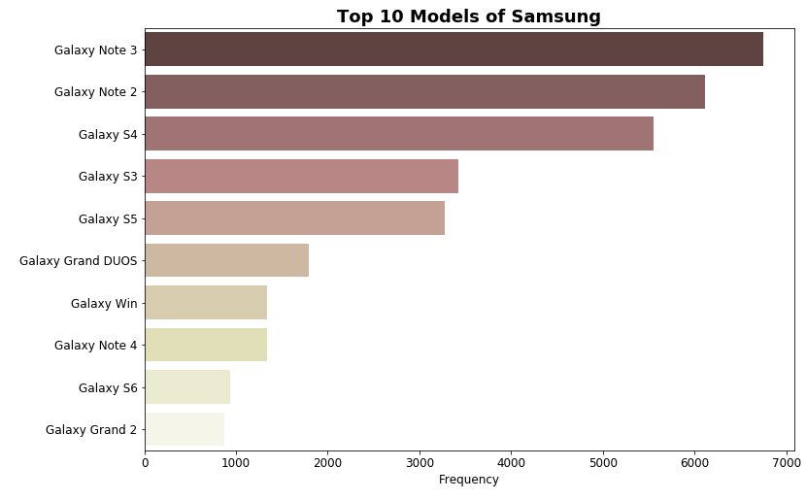

1. **Distribution of users by states**

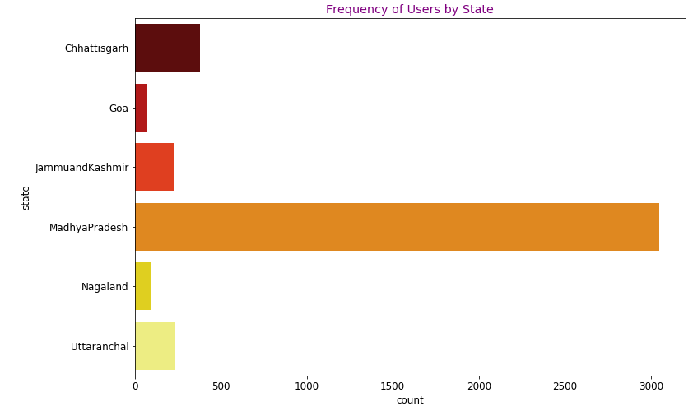

1. **Distribution of Age of users using Telecom Services**

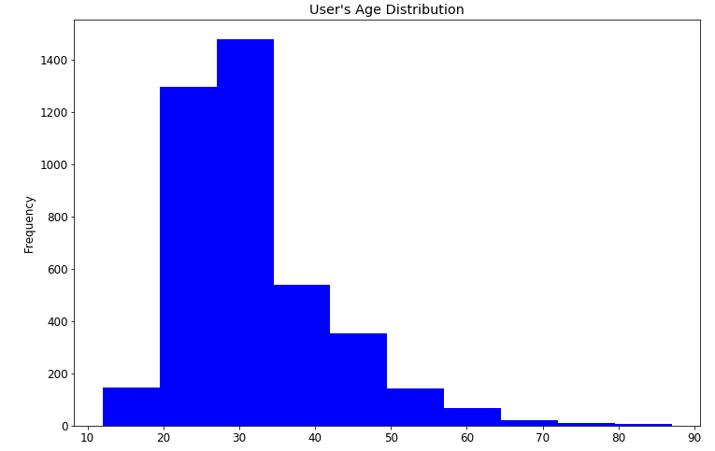

1. **Distribution of users by states and gender**

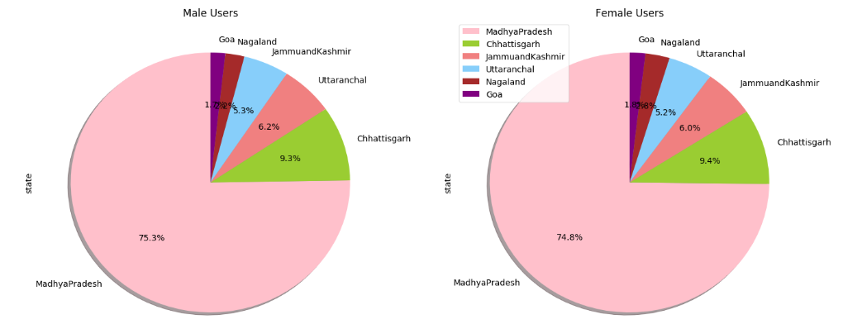

1. **Distribution of users by Age, State and Phone Brand (Top 10 phone brands)**

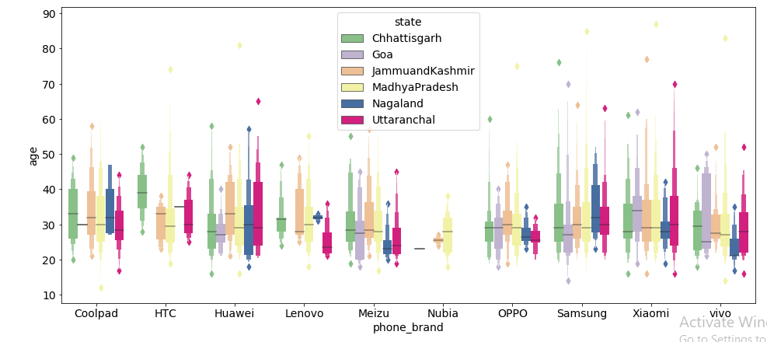

1. **Distribution of Users by Age, State Vs Group**

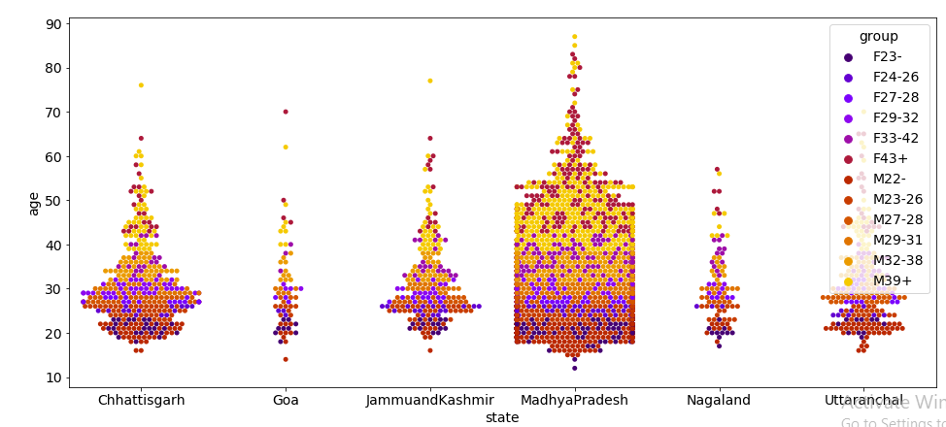

1. **Distribution of Users by City, State Vs Phone Brands(top 10)**

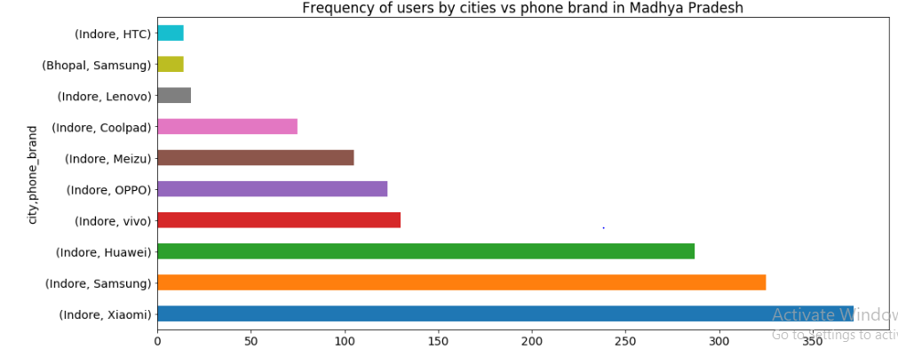

1. **Top 5 Models of one of the top 10 phone brands(Xiaomi)**

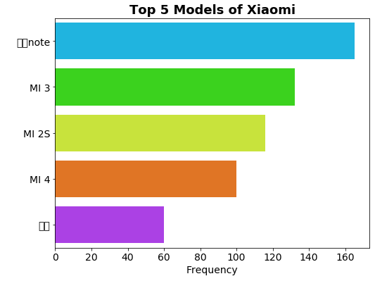

# SOURCES OF DATA

The Data is collected from mobile apps that use Insaid Telecom services. Full recognition and consent from individual user of those apps have been obtained, and appropriate anonymization have been performed to protect privacy. Due to confidentiality, we won't provide details on how the gender and age data was obtained.

Connected to database from MySQL Instance

The data schema can be represented in the following table:

1. **gender_age_train** - Devices and their respective user gender, age and age_group

|  |  |  |
| --- | --- | --- |
| **Column Name** | **Column Data type** | **Column Description** |
| age | Int64 | Age of user |
| gender | Object | Gender of user |
| Device_id | Int64 | Unique id of device belonging to user |
| Age_group | object | Age group of user |

Shape of gender_age_train is **74645 rows x 4 columns**

1. **phone_brand_device_model** - device ids, brand, and models phone_brand: note that few brands are in Chinese

|  |  |  |
| --- | --- | --- |
| **Column Name** | **Column Data type** | **Column Description** |
| Phone_brand | Object | Name of phone brand that user is using |
| Device-model | Object | Name of device model that user is using |
| Device_id | Int64 | Unique id of device belonging to user |

|  |  |
| --- | --- |
| **Brand Name** | **Brand English Mapping** |
| '华为' | 'Huawei' |
| '小米' | 'Xiaomi' |
| '三星' | 'Samsung' |
| 'vivo' | 'vivo' |
| 'OPPO' | 'OPPO' |
| '魅族' | 'Meizu' |
| '酷派' | 'Coolpad' |
| '乐视' | 'LeEco' |
| '联想 ' | 'Lenovo' |
| 'HTC' | 'HTC' |

Shape of phone_device_model is **87726 rows X 3 columns**

1. **events_data** - when a user uses mobile on INSAID Telecom network, the event gets logged in this data.  
   Each event has an event id, location (lat/long), and the event corresponds to frequency of mobile usage.

|  |  |  |
| --- | --- | --- |
| **Column Name** | **Column Data type** | **Column Description** |
| Event_id | Int64 | Event id of user using mobile at a single instance |
| Device_id | Int64 | Unique id of device belonging to user |
| Latitude | Float64 | Location column that is latitude value of user’s location when using mobile |
| Longitude | Float64 | Location column that is longitude value of user’s location when using mobile |
| Timestamp | datetime | When user is using mobile |
| City | Object | Where user is using mobile |
| state | Object | Where user is using mobile |

Shape of events_data is **3252590 rows X 7 columns**

Shape of events_data when filtered for our respective states “Madhya Pradesh, Goa, Chhattisgarh, Nagaland, Null and Uttaranchal” is **261472 rows X 7 columns**

# SUMMARY OF DATA MINING

1. Fetched data containing lakhs of records for prescribed states “Madhya Pradesh, Goa, Chhattisgarh, Jammu and Kashmir, Nagaland , Uttaranchal” and also null values for state
2. Fetched **375** 'Null' state records from database
3. Updated **'state'** column for records having cities related to our states "MadhyaPradesh","Goa","Chattisgarh",“Nagaland","Uttaranchal","Jammuandkashmir" based on **device_id.**
4. Updated state, latitude, longitude, city columns appropriately without discrepancies based on device_id
5. Dropped **290** null state records that are not of our concerned states
6. Checked for **latitude** and **longitude** containing "**0**" values and updated them with appropriate values based on **device_id**
7. Checked for **incorrect** **values** for latitude and longitude, updated them with correct values based on **device_id**
8. Fetched **67** **device_id** containing value **0** records and updated device_id for those records based on latitude, longitude values
9. Merged gender_age data frame and events_ data data frame and found **no** **null** records
10. Merged phone_brand_device_model data frame with already above merged data frame
11. There are **312** NaN's for **phone**_**brand**, **device**_**model** columns in merged data frame
12. These NaN's are filled by **mode** values from merged data frame
13. There are **no** duplicate records and our dataset is cleansed and ready for performing analysis and plotting with **261182 rows X 12 columns**
14. Unique device_id’s which represent individual user count is **4297 rows X 12 columns**
15. After filtering for **top 10 phone brand users**, we get events recorded count as **246400 rows X 12 columns,** whereas unique device_id’s count is **4061 rows X 12 columns**

# PROPOSED SOLUTION FOR CUSTOMERS

After performing Exploratory Data Analysis on all columns/variables from cleansed dataset, below are our detailed findings of how users are distributed across different cities in respective states by demographic features like gender, age, group, phone brand, etc. that would help customers(Telecom Service providers) to develop better plans and marketing strategies to increase their businesses.

1. Madhya Pradesh has high usage of Telecom Services.
2. Nagaland has least usage of Telecom Services.
3. Jagdalpur, Bilaspur, Rajnandgaon cities people are using at good pace when compared to other cities in Chhatisgarh in thousands count.
4. Madgaon, Panaji cities need more attention whereas they have very less frequency usage.
5. High frequency usage is recorded in Anantnag and Sopur.
6. Very low usage is recorded in Srinagar that city needs quite attention by our telecom marketers.
7. Very good number of users using telecom are recorded in Indore,Shahdol,Chhindwara cities in MadhyaPradesh.
8. Sendhwa, Seoni have very less users of our telecom that is less count, users are in just hundreds.
9. Less number of user events in Haridwar, Rishikesh in Uttaranchal state.
10. High Frequency of userevents are recorded in Kashipur,Rurki,haldwani in Uttaranchal state
11. There are more number of frequency usage by males, almost there is count of one lakh above and females are using at around 90000 frequency.
12. M23-26, M39+, M32-38 age groups use INSAID Telecom network more F33-42 among female group users are using Telecom network more.
13. Almost, in every state, males are using mobile more than females.
14. High frequency of Females using phones are recorded in Madhya Pradesh state and least frequency of female users using phone are recorded in Nagaland state.
15. High Frequency of Male users using phone are recorded in Madhya Pradesh and least male users recorded in Nagaland state.
16. In Jammu and Kashmir, events recorded by males in all cities have high frequency and females used mobile in very less count.
17. Male users in Indore are using Telecom extremely and Female users in Indore are using high compared to other cities female users.
18. Almost top 15 highly recorded events are by Males in respective cities in Madhya Pradesh.
19. Almost least 10 recorded events count is for female users in respective cities in Madhya Pradesh.
20. Female users using Telecom are more compared to male users in Dimapur city in Nagaland state.
21. Female users using Telecom are more compared to male users in Haridwar city in Uttaranchal state.
22. Of all the cities in Uttaranchal, female users using our Telecom is mostly reocrded in Kashipur city.
23. Madhya Pradesh has lot of outliers that is few users above age of 50-87 years are using INSAID Telecom.
24. Users in Madhya Pradesh started using Telecom at less age.
25. Uttaranchal has upper quartile high of age 60 years compared to other states.
26. Male users of above 60 are using telecom services in Chhattisgarh.
27. Female users of above 60 years are using Telecom Services in Goa.
28. Outlier present in Jammu and Kashmir are Male users.
29. Outliers in Madhya Pradesh are Female young users (females from 12-20 years age) more in compared to male users.
30. Females above 50 are using Telecom Services more when compared to male users in Nagaland. State.
31. Outlier in Uttaranchal is Male user and female users above 40 years are using Telecom Services more when compared to male users.
32. Frequency of events by state vs city vs age in Chhattisgarh:

Most of the events recorded by users of following age and cities

1.Bhilai, 40

2. Jagdalpur, 23

3.Rajnandgaon, 29

1. Frequency of events by state vs city vs age in Goa:

Most of the events recorded by users of following age and cities.

1. Mormugao, 28

2. Mormugao, 43

3. Mormugao, 38

1. Frequency of events by state vs city vs age in Jammu and kashmir:

Most of the events recorded by users of following age and cities

1. Ananthnag, 34

2. Jammu, 27

3. Udhampur, 45

1. Frequency of events by state vs city vs age in Madhya Pradesh:

Most of the events recorded by users of following age and cities

1. Indore, 24-29
2. Frequency of events by state vs city vs age in Nagaland:

Most of the events recorded by users of following age and cities

1. Wokha, 20

2. Wokha, 31

3. Kohima, 18

1. Frequency of events by state vs city vs age in Uttaranchal:

Most of the events recorded by users of following age and cities

1. Kashipur, 40

2. Kashipur, 20

3. DehradunCantonment, 24

1. Frequency of events by state vs city vs group in Chhattisgarh:

Most of the events recorded by users of following group and cities

1. Bilaspur - F43+ - 409

2. Jagdalpur - M22 - 382

3. Jagdalpur - M23-26 - 352

1. Frequency of events by state vs city vs group in Goa:

Most of the events recorded by users of following group and cities

1. Mormugao - M27-28 - 460

2. Mormugao - M39+ - 401

3. Mormugao - M32-38 - 316

1. Frequency of events by state vs city vs group in Jammu and Kashmir:

Most of the events recorded by users of following group and cities

1.Anantnag - M32-38 - 372

2. Udhampur - M39+ - 311

3. Anantnag - M23-26 - 216

1. Frequency of events by state vs city vs group in Madhya Pradesh:

Most of the events recorded by users of following group and cities

1. Indore - M23-26 - 26996

2. Indore - M39+ - 24314

3. Indore - M32-38 – 20525

4. Indore - M22 – 17925

5. Indore - M29-31 - 17505

6. Indore - F33-42 - 15427

7. Indore - M27-28 - 15414

8. Indore - F23 - 12422

9. Indore - F24-26 - 12318

10. Indore - F29-32 – 11770

1. Frequency of events by state vs city vs group in Nagaland:

Most of the events recorded by users of following group and cities

1. Wokha - F23 - 338

2. Wokha - M29-31 - 279

3. Kohima - M22 - 221

1. Frequency of events by state vs city vs group in Uttaranchal:

Most of the events recorded by users of following group and cities

1.Kashipur - F33-42 - 399

2. Kashipur - M22 - 398

3. Haldwani - M32-38 - 388

1. Top 10 Phone Brands used by people in all our selected states:

Xiaomi 63583

Samsung 53293

Huawei 48330

vivo 22638

OPPO 19749

Meizu 19059

Coolpad 12121

HTC 2942

Nubia 2531

Lenovo 2154

**Events recorded by only top 10 phone in all respective states:**

1. In Chhattisgarh:

Most of the events recorded by following phone brands in "Chhattisgarh" state

1. Samsung 2265

2. Xiaomi 1802

3. Huawei 1728

1. In Goa:

Most of the events recorded by following phone brands in "Goa" state

1. Xiaomi 911

2. Samsung 905

3. Huawei 559

1. In Jammu and Kashmir:

Most of the events recorded by following phone brands in "Jammu and Kashmir" state

1. Samsung 1603

2. Xiaomi 1051

3. Huawei 901

1. In Madhya Pradesh:

Most of the events recorded by following phone brands in "Madhya Pradesh" state

1. Xiaomi 57630

2. Samsung 45999

3. Huawei 43381

4. vivo 20264

5. OPPO 17771

6. Meizu 17470

7. Coolpad 10894

1. In Nagaland:

Most of the events recorded by following phone brands in "Nagaland" state

1. Samsung 474

2. Huawei 406

3. Xiaomi 384

4. Meizu 307

1. In Uttaranchal:

Most of the events recorded by following phone brands in "Uttaranchal" state

1. Samsung 2047

2. Xiaomi 1805

3. Huawei 1355

1. Most of the events recorded by following phone brands , gender in "Chhattisgarh" state(Helps to know which gender is preferring what type of phone brand in each state by reading respective numbers)

1. Samsung - M - 1193

2. Xiaomi - M - 1171

3. Samsung - F - 1072

4. Huawei - M - 927

5. Huawei - F – 801

1. Most of the events recorded by following phone brands , gender in "Goa" state

1. Xiaomi - M - 840

2. Samsung - M - 571

3. Huawei - F - 359

4. Samsung - F - 334

5. OPPO - M - 278

1. Most of the events recorded by following phone brands , gender in "JammuandKashmir" state

1. Samsung - M - 1009

2. Huawei - M - 716

3. Xiaomi - M - 608

4. Samsung - F - 594

5. vivo - F - 460

1. Most of the events recorded by following phone brands , gender in "Madhya Pradesh" state

1. Xiaomi - M - 34929

2. Huawei - M - 29099

3. Samsung - M - 26729

4. Xiaomi - F - 22701

5. Samsung - F - 19270

1. Most of the events recorded by following phone brands , gender in "Nagaland" state

1. Huawei - M - 302

2. Samsung - F - 300

3. Meizu - F - 244

4. Xiaomi - M - 224

5. Samsung - M - 174

1. Most of the events recorded by following phone brands , gender in "Uttaranchal" state

1. Samsung - F - 1395

2. Xiaomi - M - 1185

3. Huawei - M - 1168

4. vivo - M - 723

5. Samsung - M – 652

1. Almost in every phone brand, male users count is more.
2. Most of the events recorded by following phone brands, age in "Chhattisgarh" state.

1. Xiaomi 26 309

2. OPPO 30 269

3. Samsung 40 266

4. Xiaomi 29 240

5. OPPO 20 226

1. Most of the events recorded by following phone brands , age in "Goa" state

1. Xiaomi 28 448

2. Samsung 43 325

3. Xiaomi 38 272

4. Samsung 27 233

5. Huawei 22 172

1. Most of the events recorded by following phone brands , age in "JammuandKashmir" state

1. Huawei 34 252

2. vivo 27 215

3. Xiaomi 27 208

4. Samsung 45 195

5. Samsung 30 192

1. Most of the events recorded by following phone brands , age in "Madhya Pradesh" state

1. Samsung 29 3874

2. Xiaomi 25 3873

3. Xiaomi 26 3862

4. Xiamoi 30 3708

5. Huawei 28 3522

1. Most of the events recorded by following phone brands , age in "Nagaland" state

1. Meizu 20 244

2. Huawei 31 184

3. Samsung 48 86

4. Xiaomi 19 80

5. Xiaomi 23 73

1. Most of the events recorded by following phone brands , age in "Uttaranchal" state

1. Samsung 40 379

2. Xiaomi 24 363

3. Huawei 20 311

4. Samsung 44 230

5. Samsung 20 220

1. Frequency of events by state vs city vs phone brand in Chhattisgarh:

Most of the events recorded by following phone brands , city in "Chhattisgarh" state

1.Jadalpur - Huawei

2. Durg- Samsung

3. Bilaspur - Huawei

4. Raipur- OPPO

5. Rajnandgaon - Samsung

1. Frequency of events by state vs city vs phone brand in Goa:

Most of the events recorded by following phone brands, city in "Goa" state

1. Marmugao - Xiaomi

2. Marmugao- Samsung

3. Marmugao - Huawei

4. Marmugao- OPPO

5. Madgaon - Huawei

1. Frequency of events by state vs city vs phone brand in Jammu and kashmir:

Most of the events recorded by following phone brands, city in "Jammu and kashmir" state

1. Anantnag - Huawei

2. Kathua- Xiaomi

3. Udhampur - Samsung

4. Sopur- Samsung

5. Jammu - VIVO

1. Frequency of events by state vs city vs phone brand in Madhya Pradesh:

Most of the events recorded by following phone brands , city in "Madhya Pradesh" state

1. Indore - Xiaomi

1. 2. Indore- Samsung

3. Indore - Huawei

4. Indore- VIVO

5. Indore - OPPO

1. Frequency of events by state vs city vs phone brand in Nagaland:

Most of the events recorded by following phone brands, city in "Nagaland" state

1. Dimapur - Samsung

2. Wokha- Meizu

3. Wokha - Huawei

4. Wokha- Samsung

5. Wokha - Samsung

1. Frequency of events by state vs city vs phone brand in Uttaranchal:

Most of the events recorded by following phone brands, city in "Uttaranchal" state

1. Kashipur - Samsung

2. Kashipur- Xiaomi

3. Rurki - Xiaomi

4. DehradunCantonment- Xiaomi

5. Dehradun – Samsung

1. "Coolpad" has high count of following group users:

1. M39+ 1857

2. M32-38 1758

3. M23-26 1658

4. M27-28 1489

5. F33-42 1292

1. "HTC" has high count of following group users:

1. M23-26 886

2. M29-31 465

3. M32-38 464

4. F29-32 270

5. F33-42 229

1. "Huawei" has high count of following group users:

1. M39+ 6461

2. M32-38 5898

3. M23-26 5887

4. M22- 4936

5. M29-31 4622

1. "Lenovo" has high count of following group users:

1. F33-42 635

2. M32-38 337

3. M29-31 304

4. M23-26 266

5. F23- 153

1. "Meizu" has high count of following group users:

1. M23-26 3735

2. M39+ 2748

3. M22- 2499

4. M32-38 2334

5. F23- 1715

1. "Nubia" has high count of following group users:

1. M32-38 1281

2. M27-28 592

3. M23-26 245

4. M22- 221

5. F33-42 103

1. "OPPO" has high count of following group users:

1. M23-26 3774

2. M29-31 2903

3. M39+ 2132

4. F29-32 2070

5. M32-38 1864

1. "Samsung" has high count of following group users:

1. M39+ 7340

2. M23-26 5515

3. M32-38 5326

4. M29-31 4876

5. F43+ 4739

1. "Xiaomi" has high count of following group users:

1. M39+ 8193

2. M23-26 8036

3. M32-38 7521

4. M22- 5517

5. M29-31 5396

1. **"**vivo" has high count of following group users:

1. F23- 2965

2. M22- 2898

3. M23-26 2867

4. M39+ 2455

5. M29-31 2424

1. Top 10 Models of Xiaomi:

红米note 9149

MI 3 7680

MI 2S 6909

MI 4 6446

红米1S 4683

红米2A 3431

红米 3417

红米Note2 3120

红米2 2429

红米Note3 2259

1. Top 10 Models of Samsung:

Galaxy Note 3 6752

Galaxy Note 2 6110

Galaxy S4 5550

Galaxy S3 3429

Galaxy S5 3272

Galaxy Grand DUOS 1789

Galaxy Win 1341

Galaxy Note 4 1338

Galaxy S6 935

Galaxy Grand 2 874

1. Top 10 Models of Huawei:

荣耀6 4643

荣耀畅玩4X 3789

荣耀6 Plus 3265

Mate 7 3150

荣耀3C 2934

Ascend P7 2217

荣耀7 1721

麦芒4 1549

荣耀畅玩4C 1416

Ascend P8 1375

1. **Top 10 Models of vivo:**

X5Pro 1999

Y11 1682

Y22L 920

Y23L 906

X5SL 772

Y51 770

X5Max+ 746

X3T 710

X710L 671

S7I 657

1. Top 10 Models of OPPO:

Find 7 2616

R7s 1631

R3 1232

R6007 1026

R7 925

1107 822

R831S 811

R7 Plus 795

A31 793

R1C 697

1. Top 10 Models of Meizu:

Find 7 2616

R7s 1631

R3 1232

R6007 1026

R7 925

1107 822

R831S 811

R7 Plus 795

A31 793 R

RIC 197

1. Top 10 Models of Coolpad:

F2 2352

大神F1 2311

大神Note3 1097

8720L 859

锋尚 482

大神F2 454

大神F1Plus 438

7296 427

7295C 404

大神F2全高清版 332

1. Top 10 Models of HTC:

Desire 816

776 One 333

One max 308

One E8 285

802d 202

One S 166

Desire 820 115

Butterfly s 98

M8 98

G11 95

1. Top 10 Models of Nubia:

**My 布拉格 1174**

**Z9 Max 539**

**Z9 mini 339**

**Z5S Mini 264**

**Z7 Mini 137**

**Z5S 76**

**Z7 Max 2**

1. Top 10 Models of Lenovo:

V5S 567

星星1号 234

A880 207

G717C 205

Q505T 180

U960E 160

N986 77

Q301C 73

U795+ 70

U879 55

1. There are total 4061 user's events who are using top 10 phone brands are recorded from different cities and states.
2. There are more number of people using mobile in Madhya Pradesh alone almost 3050, and least number of people using mobile are recorded in Goa and Nagaland states.
3. Less number of users are recorded in Raigarh, Dhamtari cities and more number of users are recorded in Chirmiri,Bilaspur,Bhilai,Jagdalpur cities.
4. Mormugao has high number of users and Panaji has less number of users in Goa state.
5. Less number of users are recorded in Udhampur,Sopur, Jammu cities and high number of users are recorded in Anantnag,Baramula,Kathua cities in JammuandKashmir state.
6. High number of users are recorded in Indore and rest of cities have almost equal contribution of users in MadhyaPradesh state.
7. Less number of users are recorded in bhind,Sendhwa,Sheopur cities in MadhyaPradesh state.
8. High number of users are recorded in Kohima capital city of Nagaland state.
9. More number of users are recorded in Haldwani,Kashipur cities and less number of users recorded in haridwar city in Uttaranchal state.
10. More number of users belong to age group of M23-26,M32-38,M39+,M22,M29-31.
11. Maximum Age of Users in our concerned states: 87
12. Minimum Age of Users in our concerned states: 12
13. The mean is greater than median, a bit right skewed symmetric distribution of user's age.
14. Users are mostly of age 23-30 years old.
15. Most of the users in "Chhattisgarh" prefer using Xiaomi first, next Samsung and then Huawei.
16. Most of the users in "Goa" prefer using Huawei, then Samsung, HTC, Lenovo, Nubia brands are not used by users in Goa.
17. Most of the users in "Jammu and Kashmir" prefer using Xiaomi first,then Samsung.
18. Most of the users in "Madhya Pradesh" prefer using Xiaomi first,then Samsung and then Huawei.
19. Most of the users in "Nagaland" prefer using Samsung first,then Xiaomi and Huawei.
20. Nubia brand is not used by users in "Nagaland" state.
21. Most of the users in "Uttaranchal" prefer using Xiaomi first,then Samsung, then Huawei. Nubia brand is not used by users in "Uttaranchal" state.
22. Madhya Pradesh state has high percent of active users both male and female of around more than 50 percent.
23. Goa state has least percent of active users for both male and female of around less than 2 percent.
24. Most of the female users in Chhattisgarh are preferring to use Xiaomi, Samsung and Huawei brands and Nubia brand is not used by female users in the state
25. Most of the male users in Chhattisgarh are preferring to use Xiaomi, Samsung and Huawei brands
26. Lenovo, Nubia, HTC brands are not used by female users in goa state
27. Lenovo, Nubia, HTC , Coolpad brands are not used by male users in goa state
28. Most of the female users prefer using Samsung, Xiaomi in Jammu and Kashmir
29. Most of the male users prefer using Xiaomi, Samsung in Jammu and Kashmir
30. Most of the female users prefer using Xiaomi, Samsung and huawei brands in Madhya Pradesh state
31. Most of the male users prefer using Xiaomi, Samsung and huawei brands in Madhya Pradesh state
32. Mostly, preferred brand in Nagaland state is samsung and nubia, htc brands are not used by any female users in the state
33. Nubia and Lenovo are not used by any male users in Nagaland state whereas most preferred brand is Xiaomi
34. Most of the female users prefer using Samsung and Xiaomi whereas Nubia and Lenovo are not used in Uttaranchal state.
35. Most of the male users prefer using Xiaomi, Samsung and Huawei phone brands whereas Nubia and HTC are not used by any male users in the state.
36. Mostly, Outliers are present in Madhya Pradesh state, that is old age people are using Mobiles of our telecom network.
37. Least Outlier is present in Nagaland state that is prescribed age group persons are only using mobiles of our telecom network.
38. Almost, all states both male and female persons of similar age group 23-32 years are using mobiles of our Telecom Network.
39. Upper Quartile is high for Females in Nagaland state means female users of our network are of age till 56-58 years.
40. Lower Quartile is low for Females in Madhya Pradesh means female users of very less age started using mobiles of our telecom network that is around 12 years old 6.
41. Almost, equal distribution of users is observed for Nagaland and Utaranchal states, female users of age 25-35 and male users of age 23-32 years.
42. F43+ group users using our telecom network are mostly recorded in Madhya Pradesh , followed by Chhattisgarh states
43. F33-42 group users using our telecom network are least recorded in Goa , then followed by Nagaland
44. F29-32 group users using our telecom network are least recorded in Goa, then followed by Jammu and Kashmir, Nagaland states.
45. F27-28 group users using our telecom nework are least recorded in Goa, then followed by Nagaland, Uttaranchal states.
46. F24-26 group users using our telecom network are least recorded in Goa, then followed by Nagaland and Uttaranchal states.
47. F23- group users using our telecom network are least- recorded in Uttaranchal state, then followed by Nagaland and highly recorded in Madhya Pradesh, then followed by Chhattisgarh state.
48. M39+ group users using our telecom network are mostly recorded in Madhya Pradesh, followed by Chhattisgarh states and least recorded in Goa, followed by Nagaland states.
49. M32-38 group users using our telecom network are least recorded in Goa , then followed by Nagaland and highly recorded in Madhya Pradesh, followed by Chhattisgarh state.
50. M29-31 group users using our telecom network are least recorded in Goa, and doing good in all other states.

**which brand is mostly popular in which city? (Count of users by city and phone brand they use)**

1. Chhattisgarh:

* Bhilai Xiaomi 11
* Charoda Xiaomi 11
* Chirmiri Samsung 11
* Korba Samsung 11
* Raipur Xiaomi 11
* Dhamtari Xiaomi 10
* Durg Samsung 10
* Rajnandgaon Xiaomi 10
* Chirmiri Xiaomi 9
* Durg Huawei 9

1. Goa:

* Madgaon Huawei 8
* Madgaon Xiaomi 7
* Mormugao Samsung 7
* Mormugao Xiaomi 7
* Panaji Samsung 5
* Mormugao Huawei 4
* Mormugao OPPO 4
* Panaji Huawei 4
* Panaji Meizu 4
* Madgaon OPPO 3

1. Jammuand Kashmir**:**

* Kathua Xiaomi 12
* Baramula Samsung 11
* Srinagar Xiaomi 11 4
* Anantnag Huawei 10
* Baramula Xiaomi 10
* Jammu Samsung 10
* Anantnag Samsung 9
* Sopur Xiaomi 9
* Udhampur Samsung 9
* Jammu Xiaomi 7

1. Madhya Pradesh:

* Indore Xiaomi 372
* Indore Samsung 325
* Indore Huawei 287
* Indore vivo 130
* Indore OPPO 123
* Indore Meizu 105
* Indore Coolpad 75
* Indore Lenovo 18
* Bhopal Samsung 14
* Indore HTC 14

1. Nagaland:

* Dimapur Samsung 10
* Dimapur Huawei 9
* Kohima Xiaomi 9
* Wokha Huawei 9
* Wokha Xiaomi 9
* Kohima Samsung 8
* Kohima vivo 6
* Wokha Samsung 6
* Dimapur Xiaomi 4
* Kohima Huawei 4

1. Uttaranchal:

* DehraDunCantonment Xiaomi 11
* Pithoragarh Xiaomi 11
* DehraDun Xiaomi 10
* Haldwani vivo 10
* DehraDun Samsung 9
* Kashipur Xiaomi 9
* Rurki Samsung 9
* Haldwani Samsung 7
* Haridwar Huawei 7
* Kashipur Huawei 7

**Top 5 Models of Top 10 Brands for Users (by device id):**

1. Coolpad

* F2 40
* 大神F1 31
* 大神F2 13
* 大神Note3 9
* 8720L 8

1. HTC

* Desire 816 11
* One 9
* Desire 820 5
* G11 3
* 802w 3

1. Huawei

* 荣耀6 70
* 荣耀畅玩4X 62
* 荣耀3C 61
* 荣耀6 Plus 52
* Mate 7 50

1. Meizu

* 魅蓝NOTE 59
* 魅蓝Note 2 44
* MX4 43
* MX3 40
* MX5 23

1. OPPO

* R7 33
* R7s 25
* R7 Plus 23
* Find 7 22
* R1C 20 6

1. Samsung

* Galaxy Note 3 120
* Galaxy Note 2 102
* Galaxy S4 88
* Galaxy S3 53
* Galaxy S5 42

1. Lenovo

* A880 4
* V5S 4
* 9180 3
* Q802T 3
* U960E 3

1. Nubia

* Z9 Max 3
* Z7 Mini 3
* Z9 mini 3
* Z5S 2
* Z7 Max 1

1. Xiaomi

* 红米note 165
* MI 3 132
* MI 2S 116
* MI 4 100
* 红米 60

1. vivo

* X5Pro 26
* X5SL 18
* X5L 17
* X3T 17
* Y23L 17

# TOOLS

1. Windows Operating System
2. Python 3.7
3. Anaconda Framework
4. Jupyter Notebook
5. MySQL
6. Matplotlib
7. Seaborn

# CONCLUSION

Consulting Team provides Insights reports to customers and help understand them by numbers, how their Telecom Services have impact on users by their demographic, location features. Next customers will get to know what decision they can make in order to increase, the usage of their telecom users in respective cities, states and do more marketing in specific cities respective to age groups, genders and like other features. (Which brand users are more compatible to their services) .